Date: December 3, 2020

**Design Document**

**IAT481: Special Topics health technology (Neurotechnology, Fusion of Brain Sciences and technology)**

**Document Owners**

The contacts for questions regarding this document are:

Project Name: Nodus

Authors, Student number

1. Joycelyn Tng 301342527
2. Emily Li 301305190
3. Emma (Li Xuan) Wu 301318781
4. Adrian He 301333336

**Three supervised experts:**

1. Business aspect

* Name: Elicia Maine
* Occupation: Special Advisor on Innovation to the Vice-President Research at Simon Fraser University
* Email: [emaine@sfu.ca](mailto:emaine@sfu.ca)

1. Technical aspect

* Name: Eamon Mackisoc
* Occupation: Industrial design fabrication team member at Maker Labs.
* Website: <https://www.mackisoc.com/>

1. User aspect

* Name: Lisa Jennings
* Occupation: Retired Paramedic, Founder of You Are Not Alone PTSD BC
* Email: [lisaj911@gmail.com](mailto:lisaj911@gmail.com)

**Course Instructor:**

* Name: Dr. Sylvain Moreno

**Teaching Assistant:**

* Name: Emma Rodrigues

**Fall 2020**

**Table of Contents**

***Introduction*** ***4***

**Purpose of this document** **4**

**References** **4**

**Methodology, Tools, and Techniques** **5**

**Design Overview** **6**

**Background Information** **6**

**Business Context** **6**

**Target population** **6**

**Constraints** **7**

**Competitors** **7**

**Issues** **8**

***Scope of Work*** ***8***

**System Functions** **8**

**Similar System Information** **10**

**User Characteristics** **10**

**User Problem Statement** **10**

**User Objectives** **11**

**Performance Requirements** **11**

**Hardware** **12**

**Software** **12**

**Security Requirements** **13**

**Database Design** **13**

**Hardware Interfaces** **13**

**Communications Interfaces** **14**

**Software Interfaces** **15**

**Design Constraints** **16**

# Introduction

(Written by Emma Wu with help from everyone else)

Nodus is a wellness wristband which helps PTSD patients to detect triggers and alleviate stress symptoms. PTSD patients can wear it all day in their daily lives. The wristband predicts symptoms and offers different treatments as a response. Users of Nodus are able to tailor the treatment to suit their own preferences.

## Purpose of this document

(Written by Joycelyn Tng with help from everyone else)

The objective of this document is to provide a detailed overview of the core functions, goals, and materials that assists us in pushing our product to production. This document has been created for members of our Nodus team. It is designed to be understood by all members of a multidisciplinary team, no matter what the members specialize in. It also provides the necessary resources for all team members to understand relevant background information pertaining to our product.

## References

(Written by Emily Li with help from everyone else)

American Psychological Association (Ed.). (2017, February 24). *Clinical Practice Guideline for the Treatment of Posttraumatic Stress Disorder (PTSD) in Adults.* American Psychological Association. <https://www.apa.org/ptsd-guideline/ptsd.pdf>.

Android Developers. (n.d.). *Android Studio.* <https://developer.android.com/studio?fbclid=IwAR2GyoxvsyDoeR3hx2i6wv4d0hfZmaqAcRp9tKMisQPddNZ5T_MGTfDZ9kU>

Android Developers. (2020, October 27). *Build Wear OS apps.*  <https://developer.android.com/training/wearables/apps?fbclid=IwAR1l-uyrdzwFhU3V4SCusdmZLZWScEvXacaWeyStSqQXd9gZnjRs5GAS5Jg>

Bufka, L. F., Wright, C. V., & Halfond, R. W. (2020). *Casebook to the APA clinical practice guideline for the treatment of PTSD / edited by Lynn F. Bufka, Caroline Vaile Wright, and Raquel Halfond.* American Psychological Association.

Health Canada. (2020, November 24). Government of Canada. Retrieved December 02, 2020, from <https://www.canada.ca/en/health-canada/services/drugs-health-products/compliance-enforcement/establishment-licences/forms/medical-device-establishment-licence-application-form-instructions-0292.html>

Introduction - Wear OS by Google - Android Wear design guidelines. (n.d.). Retrieved November 28, 2020, from <https://designguidelines.withgoogle.com/wearos/wear-os-by-google/introduction.html?fbclid=IwAR0FmHDoG6t5xaseeB5KglsLxqmDOpN-El7ZvMPaQ7kWXf2yntY5axVn1EM>

Jackson, W. (2019). SmartWatch Design Fundamentals. In *SmartWatch Design Fundamentals* (1st ed.). Apress L. P. <https://doi.org/10.1007/978-1-4842-4369-5>

Justice Laws Canada. (2020, November 27). Consolidated federal laws of canada, Medical Devices Regulations. Retrieved December 02, 2020, from <https://laws-lois.justice.gc.ca/eng/regulations/SOR-98-282/>

Public Health Agency of Canada (2020, February 13). *Federal Framework on Posttraumatic Stress Disorder: Recognition, collaboration and support.* Government of Canada. <http://www.canada.ca/en/public-health/services/publications/healthy-living/federal-framework-post-traumatic-stress-disorder.html>.

Public Health Agency of Canada (2020, February 13). *Posttraumatic stress disorder (PTSD).* Government of Canada. <https://www.canada.ca/en/public-health/topics/mental-health-wellness/post-traumatic-stress-disorder.html>.

Researchers Submit Patent Application, "Wearable Care Security Smart Watch Device", for Approval (USPTO 20190328325). (2019). In *Investment Weekly News* (p. 7930). NewsRX LLC.

Tull, M. (2019, November 11). What Grounding Techniques Can You Use for PTSD? Verywell Mind. <https://www.verywellmind.com/grounding-techniques-for-ptsd-2797300>.

## Methodology, Tools, and Techniques

(Written by Emma Wu with help from everyone else)

Nodus team members are comfortable with using Slack and email as the company’s main source of communication with all other members. For prototyping and design, the applications used are Figma, Illustrator, and ProtoPie. These applications are used to create graphical components that are used throughout the application interface as well as on-screen graphics for the hardware. For 3D modeling, the application used is Rhino6, which was used to model, texture, and render the images displayed as our final Nodus Wristband prototype. The software development kit for building the Nodus application is Android Studio and Xcode. These applications are used in the development of the mobile application, as well as the wristband.

The wristband is equipped with photoplethysmography (PPG) technology which is housed within an aluminum casing and encased with a soft interchangeable silicone wristband. The sensors within the Nodus Wristband detect and make the user aware of their elevated heart rate levels, and provide grounding methods for stress-relief before the user’s stress symptoms escalate to a severe psychological episode.

# Design Overview

## Background Information

(Written by Emily Li with help from everyone else)

Nodus is designed to be a discreet wristband used by PTSD patients during their daily activities, and detect the occurrence of stress triggers. The wristband notifies the user when the heart rate increases, allowing users to be aware of their situation and begin coping methods provided by the Nodus Wristband or through the patient’s preferred methods.

## Business Context

(Written by Emily Li with help from everyone else)

With the help of *You Are Not Alone PTSD BC Associations*, the organization helps to arrange user testing and feedback during the process of our product development. Nodus Wristband does not intend to push any product to the market unless it is approved by the PTSD BC associations. A key portion of our development will be obtaining support and grants from the government fundings to help push forward with the launch of our product until we are sustainable. Additionally, we will need to obtain the Medical Device Establishment Licence (MDEL) from Health Canada.

Key Stakeholders:

Nodus Company

Consumers of the Nodus Wristband

PTSD BC Associations

Government of Canada (Health Canada)

## Target population

(Written by Joycelyn Tng with help from everyone else)

We are focusing our goals to help patients that may be distressed from the ongoing pandemic and feeling isolated from lack of human contacts. Our target end user for the Nodus Wristband is a **PTSD patient between the ages of 18-55** who is comfortable with using wearable technology. Our clients come from the demographic mentioned above, but may also be family members and close friends of the affected demographic who are wishing to help their loved ones.

*For example, Mary is a 27 year old woman who recently was diagnosed with PTSD after surviving a car crash. She does not enjoy being surrounded by constant noise and notifications her phone brings her, and hates carrying it around. Mary has frequent flashbacks that disturb her day, although she is not necessarily consciously aware when they happen. If the traumatic memories go on unnoticed Mary may escalate into a severe depressive state. Her significant other purchases a Nodus Wristband for her in hopes that it will help her manage her symptoms. The wristband helps her be aware of when she is experiencing symptoms before flashbacks and acts as a reminder to give her time to meditate and de-escalate situations before her thoughts can get out of hand.*

## Constraints

(Written by Emily Li & Joycelyn Tng with help from everyone else)

The constraints for the development of this project includes the cost of materials that are used for the product. Nodus Wristband’s target retail price is $60 making our budget to produce the wristband relatively low. This means we must pay attention to the materials used for our production. They must not be low quality and have our product fall apart or malfunction but we cannot spend too much on production costs. For instance, silicone is the main material used for the wrist strap because it is inexpensive to manufacture, lightweight, heavy-duty, and can take on different forms in comparison to other materials such as leather. Additionally, the intended weight of the wristband is roughly the total weight of 22 grams. As a result, the selected materials should be durable enough to withstand daily use comfortably. Lastly, Nodus wants to obtain a TRL 5 minimum by the second quarter of 2021 and hopefully a TRL 7 by the fourth quarter of 2021.

## Competitors

(Written by Emma Wu with help from everyone else)

WellBe, Fitbit

**Wellbe** is a bracelet and mobile app designed to indicate your stress triggers and provides an indication on the application to help alleviate the user’s stress. It also monitors the user’s heart rate and alerts the user if it detects a stress trigger.

**Fitbit** is a fitness tracker that displays health data to assist the user with their daily exercise information, heart rate, as well as general functionalities that involve smartphone activities The smartwatch has a processor as well as other features that relate to health and tracking.

**The Nodus Wristband** differentiates itself from its competitors because alongside focusing on the wellness of the user to alleviate their stress response, it also allows the user to customize their preferred treatment. With its compact design and minimal processing power, it has a much longer battery life and allows the user to continue using the device in extended intervals without worry of rapid battery drain. **As a result of a simplified detection system, the Nodus Wristband also requires less resources to manufacture. Therefore it is easy for users to adapt the product into their lives, and is more affordable than other conventional products available.**

## Issues

(Written by Emily Li & Emma Wu with help from everyone else)

The Nodus Wristband is unable to detect all precursors of PTSD symptoms from the photoplethysmography (PPG) sensor alone. For this wristband to effectively make predictions about the user’s on-coming triggers, it may need more technology to be implemented within its hardware. Moreover, the photoplethysmography (PPG) sensor cannot differentiate when the heart rate increases from triggers, or cardiovascular exercise. As a result, the Nodus Wristband has a potential to send the user alerts when they are not experiencing any PTSD symptoms.

# Scope of Work

## System Functions

(Written by Emma Wu & Joycelyn Tng with help from everyone else)

The Nodus Wristband uses a combination of haptic feedback, photoplethysmography (PPG), and bluetooth connection to provide an effective way to alert and notify the user of their elevated heart rate. It has a touchscreen interface which is simple to navigate, and does not require a smartphone to provide the user the immediate help they need to de-escalate their stress trigger.

*Figure 1* shows a flow chart of what the user process looks like when using Nodus in a hypothetical scenario, after Nodus detects an irregular heart rate.

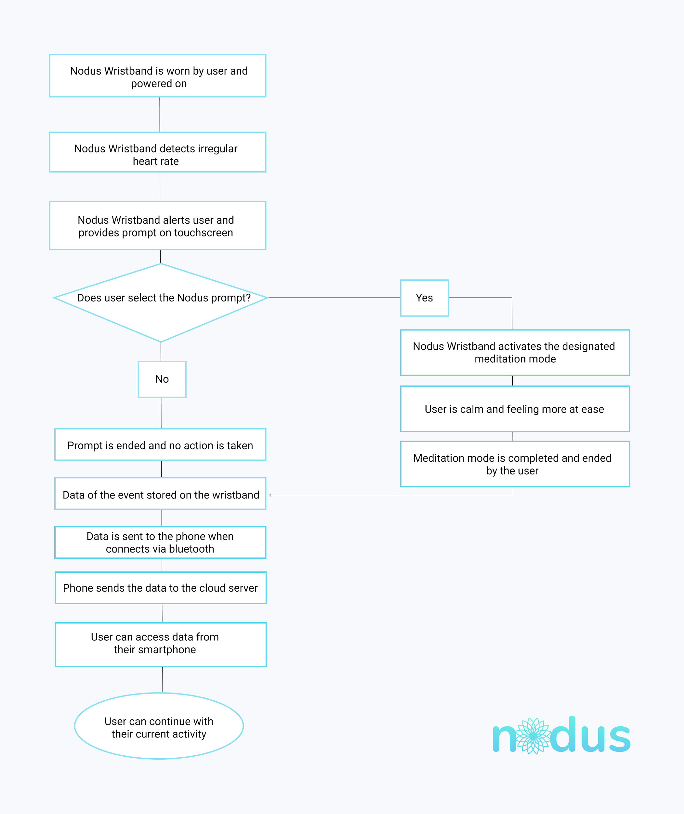

*Figure 1: System Functions Flowchart.*

When the Nodus Wristband is being worn by a user and powered on, Nodus can detect irregular heartbeat on the user through photoplethysmography (PPG). The Nodus Wristband will then alert the user using gentle haptic feedback and provide a prompt on the touchscreen. From there, the user has two options - they can either end the prompt and the screen will return to resting state, or they can activate the designated meditation mode. The user can follow the meditation exercise on the screen interface. Once they have gone through the meditation and are feeling at ease, the user can end meditation mode.

## Similar System Information

(Written by Joycelyn Tng with help from everyone else)

The main component of Nodus is the wristband. The user can also set up and connect the mobile app to their wristband in order to customize the wristband interface, meditations, and unlock other features they must do so through the application. Although it is recommended to connect the wristband to a mobile application, the wristband is able to be used solely by itself. In the event that a user connects their smartphone app to the wristband, data of each event is stored on the wristband until it can be sent to the user’s Nodus smartphone app. The wristband communicates with the mobile app via Bluetooth 5, keeping track of the date, time, and how long the symptoms last when an abnormal heart rate is detected. The smartphone app sends the user’s data to our secure cloud server where the data can be accessed from the user’s smartphone. Our cloud server sends weekly user reports containing the data which is deleted from our server after the reports are sent.

## User Characteristics

(Written by Emily Li with help from everyone else)

Our users are PTSD patients looking for a product that will predict when symptoms occur and assist the users in developing grounding techniques. These users are also people who have owned or used a smartphone with a touch interface. They are aware of the implications of wearable technology and the general use of digital interfaces that require user input. The Nodus Wristband notifies users when it predicts potential symptoms; from there, users will direct their attention away from what triggered them and begin their grounding technique. With the wristband, PTSD patients can learn their symptoms and find their unique coping mechanism that will help them from going into a flashback or dissociation.

## User Problem Statement

(Written by Emily Li with help from everyone else)

Adult PTSD patients are experiencing more distress in the ongoing months of the current pandemic as increased frequency of anxiety symptoms occur unexpectedly throughout the day. Some PTSD patients may not recognize immediately that they have triggered their symptom; therefore, they are unable to collect themselves and start any meditations or grounding techniques. Nodus Wristband is made to help patients to recognize their symptoms and adapt their personal methods to cope with them. The wristband can be worn throughout the day and can be triggered regardless where the user may be located. With predicting symptoms, users are able to be aware of their current state and potentially avoid escalating further.

## User Objectives

(Written by Joycelyn Tng with help from everyone else)

Our users are looking for a way to manage and alleviate their symptoms of PTSD. Ultimately our users want to minimize their PTSD symptoms as much as possible and live their lives without constant daily disturbances and emotional distress. Our user feedback geared towards a discreet and comfortable wearable wristband.***Users do not want to be targeted by others for being different.* A requirement for many PTSD patients when it comes to wearable technology is that the technology does not stand out or make them feel strange or different.** Nodus Wristband focuses on customizability to provide the best option for PTSD patients to feel comfortable with our product. *Our product is designed to look similar to existing smartwatches out on the market so as not to stigmatize our users and allow them to feel safe when wearing a health device.* User experts are excited to see increased options offered to the PTSD community.

## Performance Requirements

(Written by Joycelyn Tng and Adrian He with help from everyone else)

Nodus has copper contacts on the rear side of the device for recharging purposes. The battery must have a long life in order to allow the user to wear it freely throughout the day. The build of the product has the proper rubber seals to prevent liquid from entering the electronic component of the wristband when worn in outdoor situations. The PPG sensor is placed on the underside of the wristband where it makes contact with the person's wrist as it must be placed in a position where it is able to detect the user’s heartbeat accurately in order for Nodus to detect symptoms as intended. The haptic vibration we use in our wristband must be discreet enough as users want the device to be inconspicuous as possible. Furthermore, Nodus Wristband must have a flexible and ergonomic design in order to best fit the comfort of our users’ wrists. The final product should not make the user feel different or out of place when wearing the wristband in public.

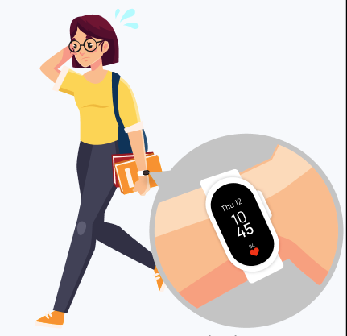

## Hardware

(Written by Adrian He with help from everyone else)

* 3.1 x 1.5cm aluminum alloy watch body
* Silicone for watch band 24 cm (full details is in hardware interfaces section)
* 200mAh Li-Polymer Rechargeable battery, 3.7v
* Amoled Touch Screen display 28mm or 2.8cm diagonal screen display size
* PCB including CPU, Bluetooth 5 chip, eMMC NAND flash storage, 1GB RAM
* Motor for haptic feedback/vibration
* 8 inch dedicated magnet charging cable, 2 pin to male USB-A

## Software

(Written by Adrian He with help from everyone else)

For prototyping, Figma is used to wireframe and design user interfaces, which has the benefit of allowing individuals to collaborate together and see changes and suggestions live. ProtoPie is also used to prototype the more complex designs as it offers a robust prototyping interface. ProtoPie can also be run on embedded devices and has custom event handlers, allowing prototypes to function close to their final built versions. After creating prototypes, the Software Development Kit’s (SDK) for building the Nodus companion application are Android Studio and Xcode. Built with Android Application Package (APK) for the Android version and in Swift for iOS, Nodus runs on Android (version 5.0+) and iOS (version 10.0+). The custom watch OS is built on top of Wear OS due it already being well developed by Google as well as it being an open source OS.

## Security Requirements

(Written by Adrian He with help from everyone else)

For our app’s storage system security, an SSL (Secure Sockets Layer) is necessary for HTTPS to secure usernames, passwords, and important data transmitted between a device and the server. SSL is a type of asymmetrical cryptography which is mathematically complex and difficult to reverse-engineer, therefore it is quite secure. Sensitive user data should not be backed up nor stored outside of the app’s storage system.

The app adheres to iOS and Google app store policies for privacy and control requirements. The type of data collected, how it’s collected, how it’s used, how it’s shared, and data retention and deletion policies are clearly stated in a Terms and Condition agreement. Basic access to system hardware is automatically granted for iOS while on Android, the user can choose what access the app gets upon opening the app for the first time.

<https://www.apa.org/ptsd-guideline/ptsd.pdf>

Concerning our target population, PTSD is a sensitive topic which everyone in our team must learn to understand as well as respect the condition. With the guided research and information from the American Psychological Association, the Nodus team can follow the recommended methods and approach to PTSD patients. Moreover, our team is following the proper steps guided by the Public Health Agency of Canada’s PTSD framework. *See 1.2 References.*

## Database Design

(Written by Adrian He with help from everyone else)

Nodus uses a relational database management system which allows for information to be structured to support relationships between the pieces of information. Structured Query Language (SQL) can be used to filter and combine datasets and formatted into spreadsheet-like tables. Tables of data can be easily updated without disrupting the entire dataset as well as having the ability to limit access to certain sets of data within a particular group. Data is stored locally until it is automatically or manually pushed to cloud servers that are tied to an individual's account token. SQL allows for faster query processing - several large changes can be done quickly and efficiently. SQL servers offer various security features and enhanced performance with low running costs. Servers can be easily scaled up when needed. Tokens ensure that Personally Identifiable Information (PII) can be successfully located, restored, and/or deleted.

## Hardware Interfaces

(Written by Adrian He with help from everyone else)

The main component of the wristband features an AMOLED touchscreen display, encased in an aluminum housing. When pressed, the side button brings the user back to the homescreen. The rear of the main wristband body houses a heart rate sensor. There are two high-intensity infrared green (IR) lights and a photosensor in the middle, creating the photoplethysmogram that detects the user's heart rate. The silicone wrist strap is adjustable by length, and can be interchangeable with different styles.

Silicone Wristband Details:

Thickness 0.2cm

Length 24cm

Width 2.1cm

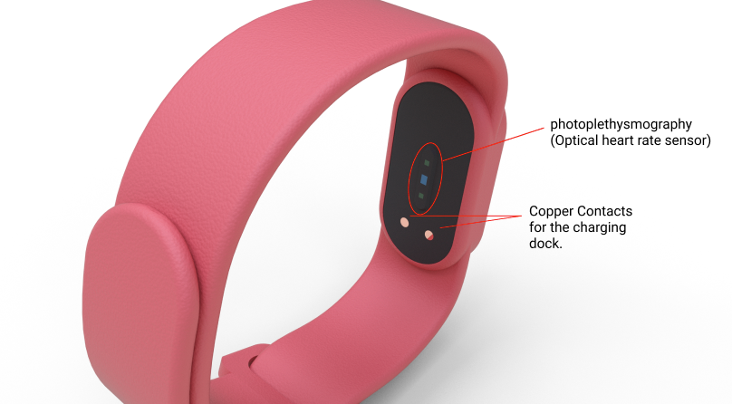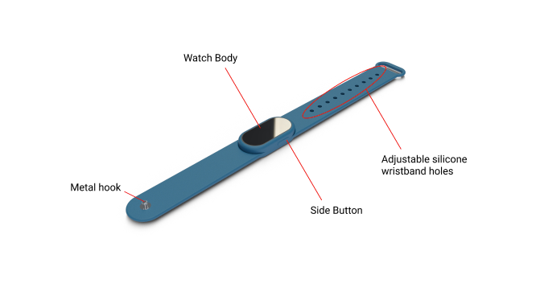

## Communications Interfaces

(Written by Adrian He with help from everyone else)

The wristband communicates with the accompanying Nodus smartphone app with the use of Bluetooth 5 low energy technology. It uses two protocols, GAP (Generic Access Profile) and GATT (Generic Attribute Profile) to communicate. The data within the app is stored within an AWS cloud server for a user specific token. The user data is backed up on a separate Nodus server, which can be accessed, pulled or deleted for user data protection.

## Software Interfaces

(Written by Joycelyn Tng with help from everyone else)

Our software interfaces appear on the watch screen and on the mobile app. The watch screen interface is quite simple and has three main components: resting state, active state, and treatment state.

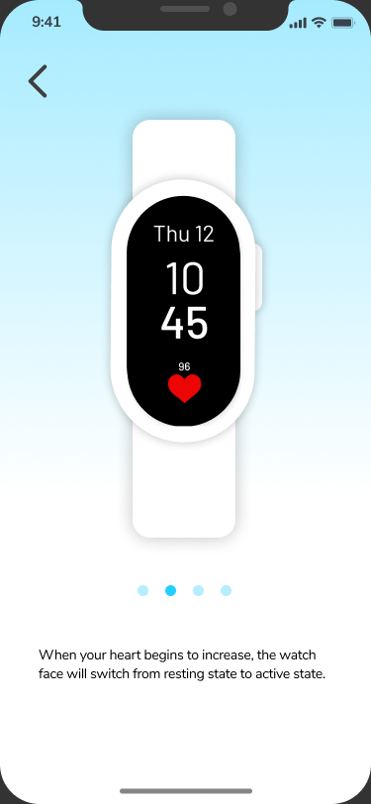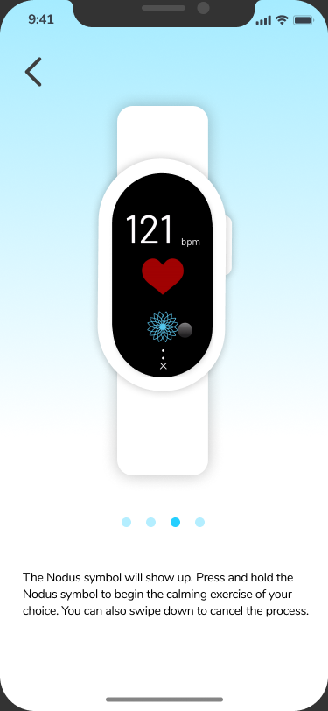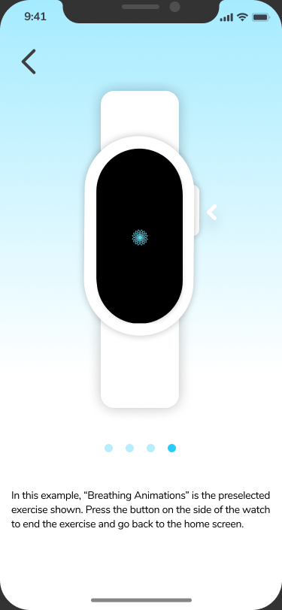

The mobile app has five main components stemming from the home page: recent activities, watchface therapy customization, home screen customization, subscription options, and a how to use page. [Figma Mobile App Prototype](https://www.figma.com/proto/2wb5HgjEBKIdz6URVdhk3C/IAT-481-Slides-prototype?node-id=235%3A145&viewport=-131%2C-477%2C0.415619820356369&scaling=min-zoom)

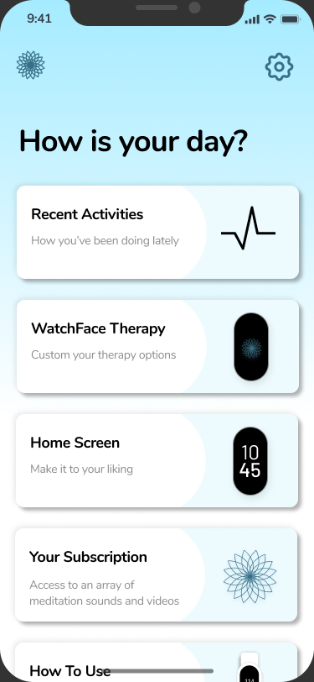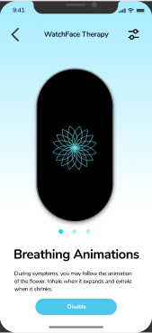

[ProtoPie Link](https://cloud.protopie.io/p/0b9949f028/11?ui=true&mockup=false&touchHint=true&scaleToFit=true&cursorType=touch) // [Video Link](https://youtu.be/h6NkTtkEAQ0) (If the ProtoPie does not work)

Here are links to a scenario of our wristband interface. In this Protopie prototype, it runs through how a user uses the wristband during a trigger event. To start the interaction, select anywhere on the screen. The scenario starts as if the user's heart rate is increasing because of a trigger.

## Design Constraints

(Written by Emma Wu with help from everyone else)

As for the wristband design, considerations such as the flexibility sizes in the wrist strap to fit most average adult wrists. The length of the wristband’s electronic component cannot exceed 3.5 centimeters to fit comfortably on the user's wrist. The wrist strap holes in the wristband are spaced 0.6 centimeters apart to accommodate a variety of adult wrist sizes as the wristband must fit snugly in order for the PPG sensor to function properly. In addition, the amoled screen is slimmer in width to be aligned with the wrist strap, so as to not create unnecessary weight on the users’ wrist. As for the digital interface, the black background allows an inconspicuous on-screen display as well as saves on battery life. The wristband does not draw unwanted attention towards the user, and its silicone wrist strap should be comfortable for daily use for quick and easy activation of the Mediation Mode during use.